Meeting Venue & Accommodations
Bordeaux, France
The IVC & NUVA Expert Summit will take place at the Radisson Blu Hotel, located at 63 Rue Lucien Faure Dock G6, Bordeaux, France.
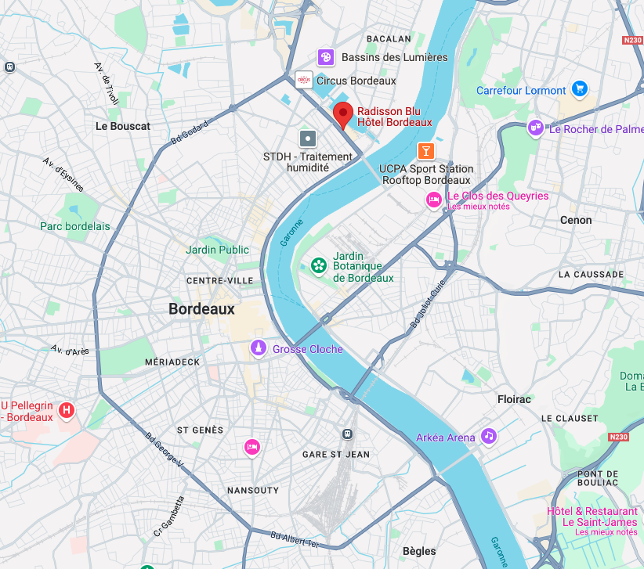
Bordeaux, renowned for its world-famous vineyards, is an elegant city with stunning 18th-century architecture, tree-lined boulevards, and a vibrant cultural scene that rivals even Paris.
The Radisson Blu is situated in the Bassins à Flot district, a former industrial port area now transformed into a dynamic urban hub. Spanning 160 hectares, this redeveloped waterfront district blends modern architecture with historic charm, offering a mix of cultural, leisure, and business opportunities—making it an ideal location for collaboration and networking.

Getting to Bordeaux
- By Air ✈️: Bordeaux–Mérignac Airport (BOD) is the nearest international airport, with direct flights from major European hubs and connections from North America.
- By Train 🚆: Bordeaux is well connected via TGV high-speed trains, with a journey time of approximately 2 hours from Paris (Gare Montparnasse).

Local Transportation
- Tram & Bus 🚋🚌: The Bordeaux tram network provides easy access to the city center and surrounding areas, with a stop near the Radisson Blu.
- Taxi & Ride-Sharing 🚖: Readily available throughout the city.
- Walking & Cycling 🚶‍♂️🚲: Bordeaux is pedestrian-friendly, with bike rental services for convenient short trips.

Recommended Hotels
- Radisson Blu Bordeaux (Meeting Venue)
  - Location: On-site at the summit venue
  - Rate: €170 per night (including tax, breakfast, and single occupancy)
  - Tourist Tax: €3.74 per person per night
  - Booking: To secure this rate, submit the completed reservation form to romain.toulgoat@radissonblu.com
- Quality Hotel Bordeaux Centre (City Center, near shopping & dining)
  - Location: In the heart of Bordeaux, ideal for exploring the city
  - Room Rates: €155–€200 per night (depending on options)
  - Travel Time to Venue: 🚋 25-30 min by bus (num 5) or 🚖 15 min by taxi
- Hotel Konti Bordeaux (Historic District, Golden Triangle)
  - Location: Near the old city center in a restored 18th-century mansion
  - Room Rates: €141–€200 per night (depending on options)
  - Travel Time to Venue: 🚋 25-30 min by bus (num 5) or 🚖 15 min by taxi

Traveling to Venue
Bordeaux has an efficient and easy-to-use public transport system, making it simple to navigate the city. The Tram B line connects the city center to the Bassins à Flot district, where the summit venue is located. Trams run frequently, and a single TBM ticket costs €1.90, valid for one hour across all tram, bus, and riverboat routes. Paper tickets can be recharged up to 10 times, making them a convenient option for multiple trips. Tickets are available at station kiosks or via the TBM app.
For short distances, walking and cycling are excellent ways to get around. Bordeaux is a pedestrian-friendly city with dedicated bike lanes, and VCub public bike rentals are available throughout the city. Taxis and ride-sharing services like Uber and Bolt are also convenient options for door-to-door transport.
From Airport by Taxi/Car | The airport is located 16km away.  Approximately 25 minutes.
From Airport by Tram | Take tram A to Hotel de Ville, transfer to Tram B, then get off at La Cité du Vin and walk 650 meters down Rue Lucien Faure.  Approximately 1 hour 15 minutes.
From the train station by tram: | Take tram C to Les Quinconces, transfer to Tram B, then get off at La Cité du Vin and walk 650 meters down Rue Lucien Faure.  Approximately 30 minutes.
From the train station by train/bus: | Take the TER (regional train) to Cenon (first stop), then take bus 32 towards Bouliac Centre commercial and get off at the Bassins à flot.  Approximately 35 minutes.
From Quality Hotel | Take the bus number 5 at “Gambetta” stop, towards “Bassins à flot” then get off at the “Faure-Brunet” stop. Or catch Tram C at “Grand Théâtre” in the direction of “Berges de la Garonne” and get off at the “La cité du vin”.  Approximately 30 minutes.
From Hotel Konti | Take the bus number 5 at Gambetta going towards “Bassins à flot” then get off at Faure-Brunet. Or take Tram C from Gambetta going towards Berges de la Garonne, then get off at La cité du vin.  Approximately 30 minutes.

Extend Your Stay in Bordeaux
For those considering staying the weekend, Bordeaux in May offers pleasant spring weather, making it an ideal time to explore the city's rich history, world-renowned wines, and scenic riverfront. Whether you prefer cultural landmarks, outdoor activities, or culinary experiences, Bordeaux has something to offer.
- Experience the Wine Capital of the World – Take a short trip to the Médoc, Saint-Émilion, or Pessac-Léognan wine regions for tastings at historic châteaux. For a closer option, visit La Cité du Vin, an interactive wine museum just minutes from the summit venue.
- Discover Bordeaux’s Historic Center – Stroll through Place de la Bourse, the Miroir d’Eau (water mirror), and the UNESCO-listed old town, where charming squares and elegant 18th-century buildings define the city’s character.
- Enjoy the Garonne Riverfront – Walk, cycle, or take a river cruise along Bordeaux’s scenic quays, where you’ll find lively markets, cafés, and stunning views.
- Explore the Dune of Pilat – Just 40 minutes from Bordeaux, this is Europe’s highest sand dune, offering breathtaking views of the Atlantic Ocean and the Arcachon Bay.
- Taste the Local Cuisine – From fresh oysters from Arcachon Bay to the famous canelé pastry, Bordeaux is a food lover’s paradise. The Marché des Capucins is the go-to spot for fresh local specialties.
While the International Summit on Vaccine Coding & Standards is the priority, extending your stay provides a perfect opportunity to experience the best of Bordeaux while engaging with global vaccine coding experts in a vibrant, historic setting.

